**Documentation: Getting started**

Below Steps has been followed to complete the project

1. Prerequisites:

* Python 3.9, PIP
* Visual Studio Code
* Django pkg

1. Create a virtual environment:

* Install & create:s

pip install virtualenv

virtualenv <env_name>

or,

* To create a virtual environment in a given directory, type:

python -m venv /path/to/directory or,

python3 -m venv <env_name>

* On Unix or MacOS, using the bash shell activate the virtualenv:

source /path/to/venv/bin/activate or,

source <env_name>/bin/activate

Eg: source ecp/bin/activate

1. Install DJANGO packages: pip install django

python - -version - ->3.9.12

django-admin - -version - ->4.0.3

1. Different files in Django Root Directory

* **Manage.py file:** This file is used as a command-line utility for projects. This file is used for debugging, deploying, and running web applications.It performs the same things as django-admin but also provides some project-specific functionality.

**Project Files**

* **urls.py file:** It contains all the endpoints that a website should have.
* **settings.py file:** It contains the Django project configuration.The setting.py is the most important file, and it is used for adding all the applications and middleware applications.
* **__init.py_ file:** This is an empty file. The function of this file is to tell the Python interpreter that this directory is a package and involvement of this __init.py_ file in it makes it a python project.

**Application Files**

* **Admin.py file:** This is used for registering the Django models into the Django administration. It performs three major tasks: Registering models, Creating a Superuser and Logging in using the web application
* **Apps.py file:** This is a file that is used to help the user include the application configuration for their app.
* **Models.py file:** This represents the models of web applications in the form of classes. Models define the structure of the database.
* **Views.py file:** Views provide an interface through which a user interacts with a Django web application. It contains all the views in the form of classes.
* **Urls.py file:** This works the same as that of the urls.py in the project file structure. The primary aim being, linking the user’s URL request to the corresponding pages it is pointing to.
* **Tests.py file:** This allows the user to write test code for their web applications. It is used to test the working of the app.

1. Create django project: django-admin startproject <project-name>

Eg: django-admin startproject shoppycom

* Again, activate the virtual env: source ecp/bin/activate
* Migrate: python manage.py migrate
* Run the server: python manage.py runserver

Server started at <http://127.0.0.1:8000/> [See attached Snapshot below]

* Rename the application (optional) : python manage.py rename <current> <new>

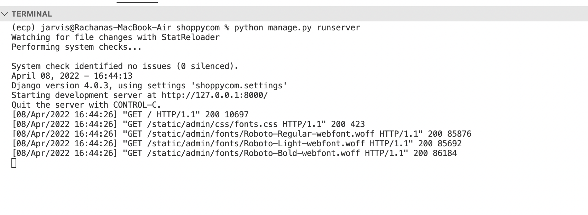

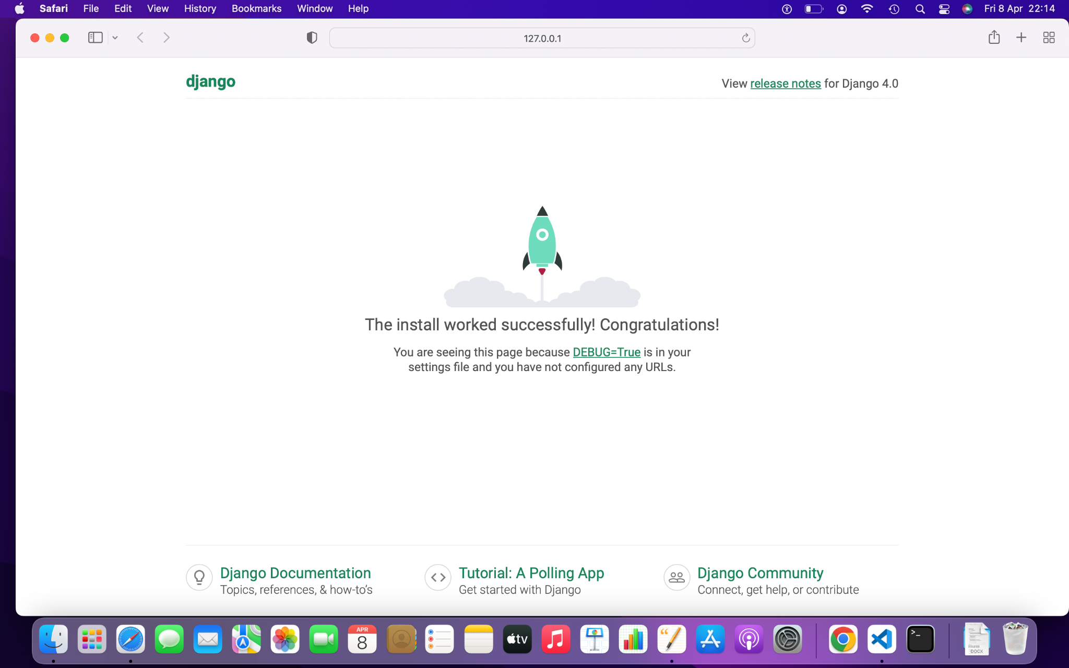

1. Create django application: python manage.py startapp <app_name>

* For this project I’ve copied the application folder from<https://github.com/geekyshow1/shoppinglyx.git> repo to my project Shoppycom.

**Steps**:

* Clone or download ZIP from above github url,
* Unzip and copy the app folder to the project
* ADD/INSTALL Applications to django project: Updated shoppycom/settings.py file by adding application name “app” in INSTALLED_APPS
* Update shoppycom/urls.py file by adding below: **path('', include('app.urls'))**, So that Django function can find urls of “app”, And can render it.
* Run the server and the app started loading.

1. Create templates, static folder inside “apps” [Already present in apps folder]
2. Modified models.py file inside “app” and Run below command to generate db models/tables/migration files

* python manage.py makemigrations
* python manage.py migrate

Model Created: Customer, Product, OrderPlaced, Cart

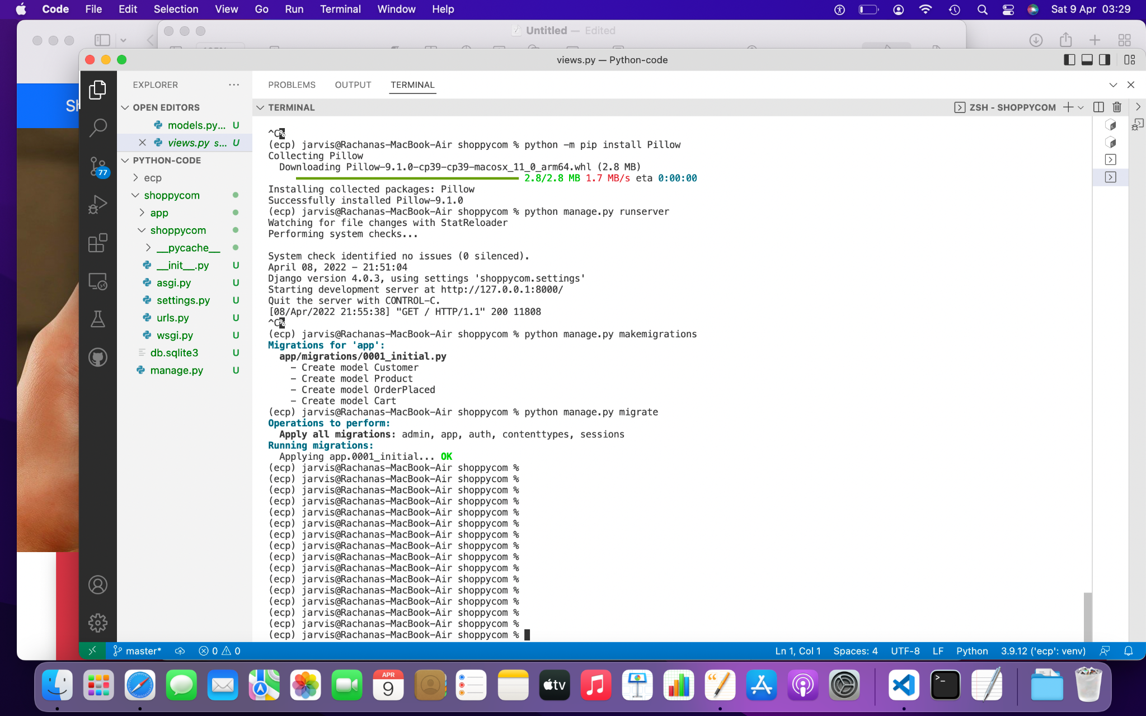

Error :: Cannot use ImageField because Pillow is not installed.

HINT: Get Pillow at https://pypi.org/project/Pillow/ or run command "python -m pip install Pillow”.

1. Register with admin portal by creating a Super user: 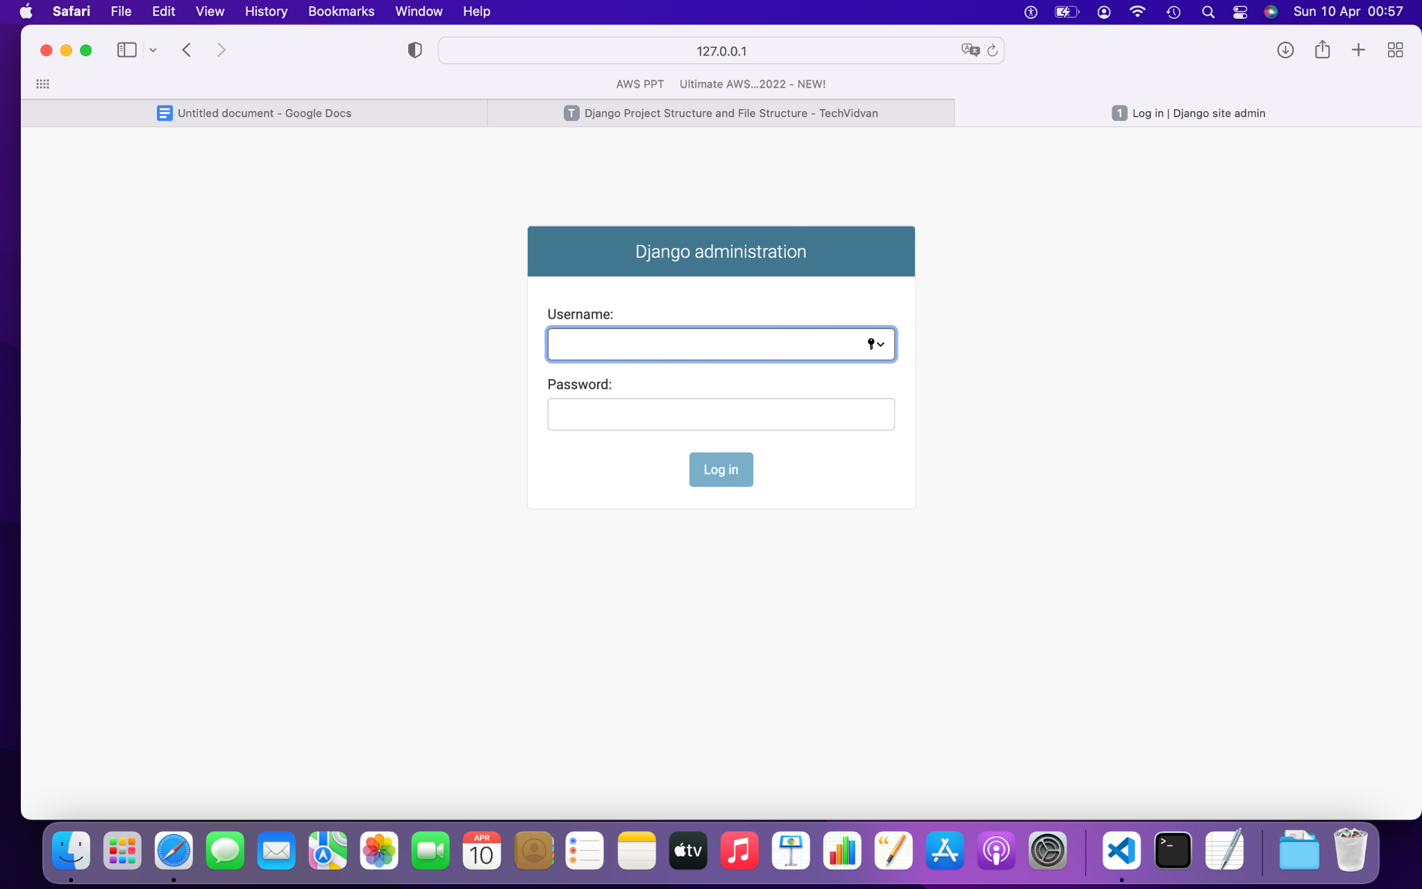

python manage.py createsuperuser

Username (leave blank to use 'jarvis'): admin

Email address: <empty>

Password: shoppycom

Password (again): shoppycom

Superuser created successfully.

Run server again: <http://127.0.0.1:8000/admin/>

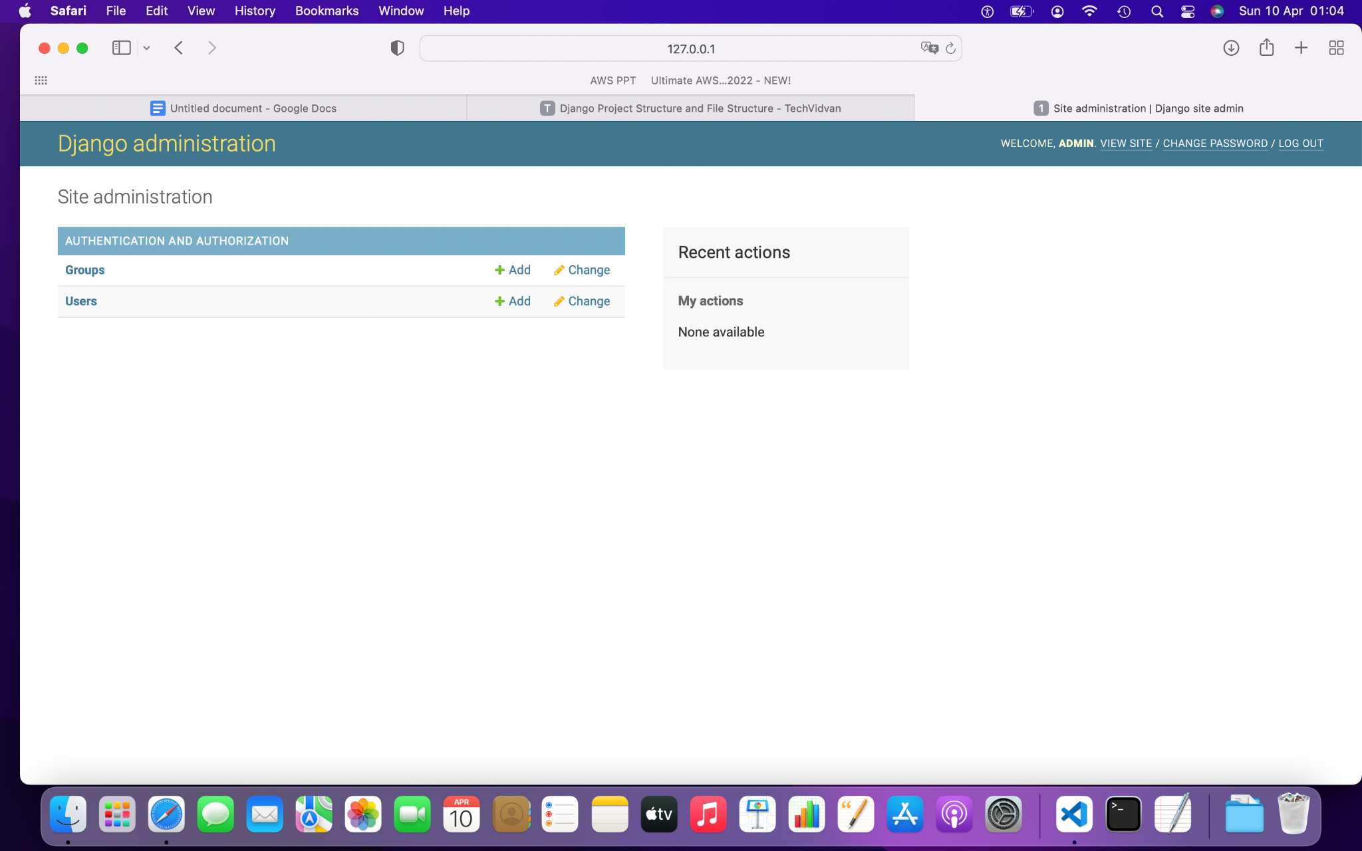

10 apr:

Registered models with django admin via admin.py

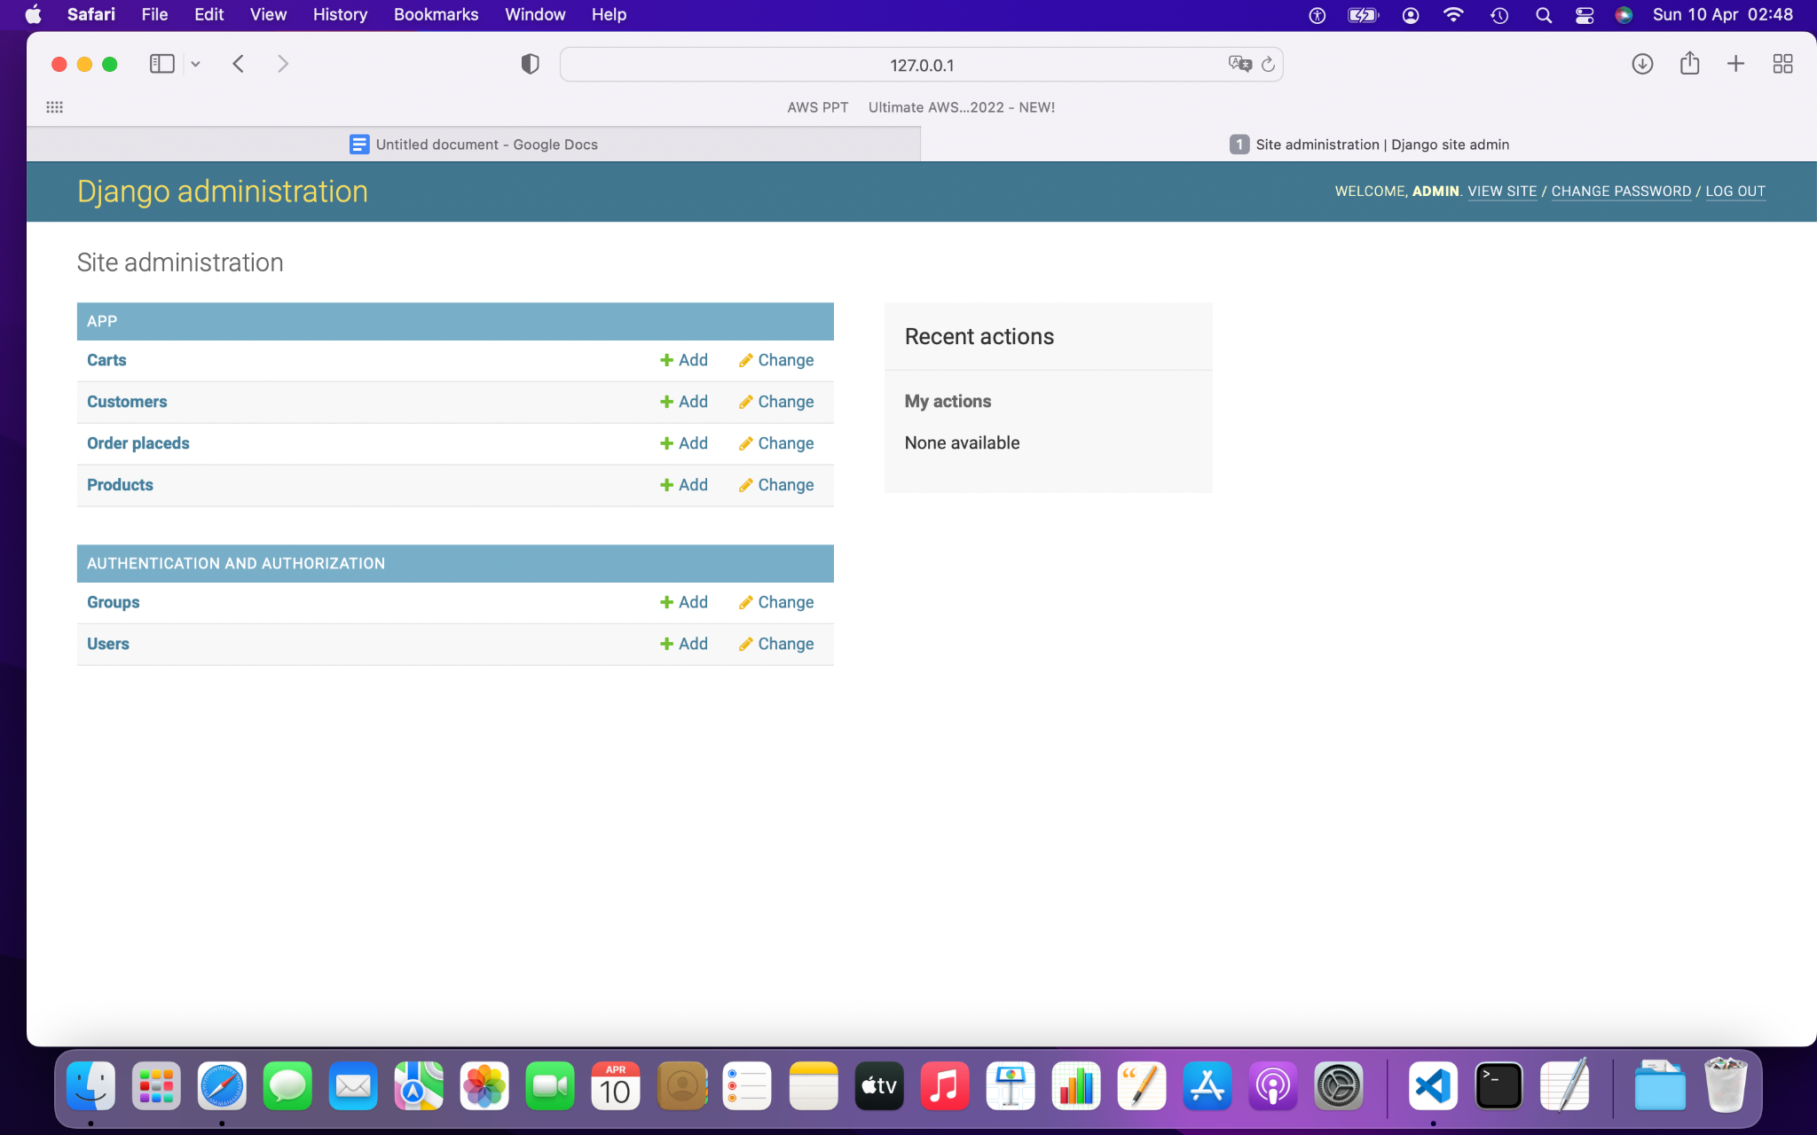

# Defined path for storing media in settings.py file

MEDIA_URL = '/media/'

MEDIA_ROOT = BASE_DIR / 'media'